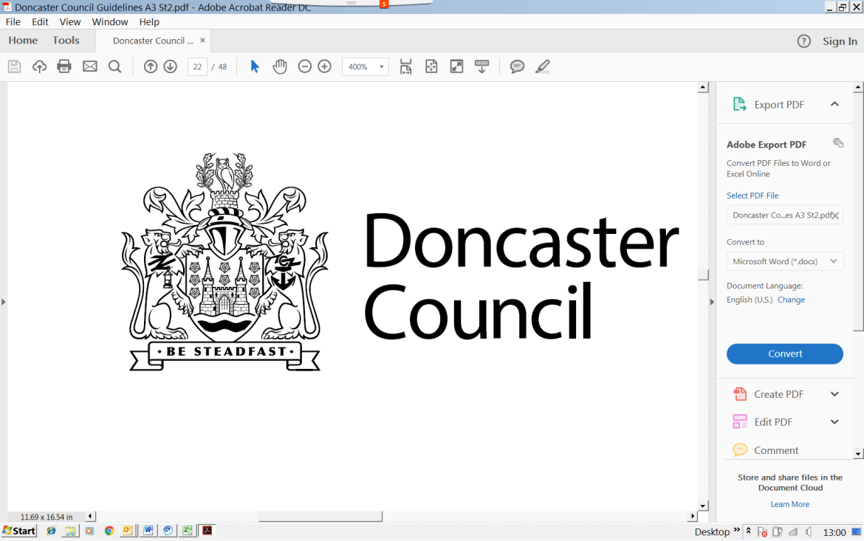

****Community Engagement Toolkit

2018-2021

**Leadership Team Sponsor (s):** Lee Tillman

**Cabinet Portfolio:** Portfolio Holder for Communities, Voluntary Sector and the Environment

**Corporate Plan Theme**: All

**Approval Information:**

Directors:

Executive Board:

Cabinet:

**Next Review Date:** March 2021

Contents

The Ladder of Engagement 4

Listening 4

Information Giving 4

Consultation 4

Co-Production 4

Supporting Citizen Power 5

Stakeholders 6

Purpose 6

Potential Barriers to Engagement 6

Overcoming Barriers to Engagement 7

Consider 7

Methods and Techniques 7

Community Mapping 7

Modelling 8

Public Meetings / Existing Meetings 8

Focus Groups and Workshops 8

Citizen Panels 8

Hackathon 8

Face to Face interviews 8

Social Media and web based discussions 8

Drop in Sessions 9

Art and Creativity 9

Surveys 9

Policy Statements 9

Introduction

Our Community Engagement Policy[1] sets out what is important and why engagement with residents, communities and businesses is important to the Council’s vision to ensure Doncaster and its people thrive.

This Community Engagement Toolkit has been developed to support the process by which the Council, community organisations and individuals build ongoing, permanent relationships for the purpose of benefitting the community.

This toolkit is part of the Community Engagement Framework;

# The Ladder of Engagement

Community Engagement can take a number of different forms, and which you use will depend upon what it is that you are trying to achieve. Below is a diagram showing the “Ladder of Engagement” which shows the different levels and methods of engagement.

### Listening

We will listen to what people have to say, showing that we have understood their point of view, be attentive and non-judgemental, clarifying questions where necessary, with empathy and with appropriate feedback

### Information Giving

This form of Community Engagement consists of simply providing information to people.

This is where a decision has already been made and the Council is informing the Public of something.

An example might be the Council letting people know what day of the week their area will have refuse collections, or informing people of where their nearest polling station is for an election.

It is important to note that, if a decision has already been taken about a service or policy change, but it is felt there is a need to engage the public, and then the nature of that engagement should be about providing information and letting the public know that they cannot change this decision

### Consultation

A consultation is a formal discussion about a problem or question to which a decision is required.

It involves taking into account and listening to the views of those being consulted before a decision is made

### Co-Production

Co-production is working with others to produce an outcome. This could be citizens being involved in the creation of public service delivery, policies and strategies. It could also involve citizens being part of the conception, design, direction and management of services

### Supporting Citizen Power

Citizen Power is where the Council allows a more active participation of citizens and community groups in the decision making process or the Council supports community led initiatives

Planning your Community Engagement

When planning your Community Engagement activity, consider the following:

* Start with the end in mind – what do you want to achieve by carrying out this consultation or engagement exercise?
* Has there been previous engagement on this subject which can add value to yours?
* Is this engagement authorised by a decision maker?
  + How will you feedback regarding progress and changes if it is not delivering what you originally expected
  + Have you briefed your Cabinet Member?
* Have you registered on the Council’s Consultation website?
* Produce briefing papers and background information
* Research and data relating to the issue or proposals
* A report showing the “before the consultation” state, and a report showing the state after the consultation
* Time constraints, communication methods, promotion, venues, transport
* Limits and constraints
  + Due to budget (explain these in your discussions with stakeholders)
  + Explain Council Policy and legislative boundaries
  + Explain what is in scope and what is out of scope
* How and when decisions will be taken and communicated back to stakeholders
  + Justify decisions and what will happen next
* Is your consultation material easy to understand by the “man on the street” or is it full of Council Jargon and acronyms.
* How many people do you want to engage with?
* How will you identify your audience?
  + Is there a representative for the group(s)
* How will you communicate with stakeholders
  + Can you use/brief Ward Councillors
  + Is your website up to date?
  + Is there an online consultation platform that you can use?
  + Community Notice Boards
  + Local Businesses
  + PACT Meetings
  + TARA meetings
  + Parish Council Meetings
  + Local Churches
  + Doctor Surgeries
  + Schools
  + Community Leaders
  + Be welcoming, friendly, polite and approachable, have empathy
  + Target engagement to those with an interest in the topic
  + Can you advertise in quarterly village magazines or local newspapers?
  + Have you considered using radio to promote the consultation or engagement event?
  + Consider an evening and/or weekend event for those who work during the day
* What resources do you have (e.g Budget for materials (and staff), who will carry out the engagement, develop the paperwork and information, communicate with the Communications Team, use Social Media)
* Who will carry out the engagement?
  + Can you use frontline staff to get messages across or gain insight from communities?
  + Can you produce a web page?
* Is the information in a format suitable to the audience?
* What impact will the proposals have on your audience?
  + Are there any mutual benefits to the proposal?
* What are the limits of your engagement?
* Plan in timely feedback and how you will feedback to your stakeholders (e.g. you said we did)
* Have regard to Equality legislation
* Evaluation of your consultation to inform future engagement processes
* Make every contact count – are there other messages you could get across or services you could refer to whilst talking to your audience?
* Is there other engagement already planned by another team that you could team up with?

### Stakeholders

* Members and Cabinet Leads
* Local resident or area based groups
* Communities of interest
* These effected (e.g. Schools, Area Teams, local residents/home owners (as individuals), other Council teams)
* Faith groups
* Racial, ethnic and cultural groups
* Existing networks including community and voluntary groups
* Web based social media groups
* Local Businesses

### Purpose

What is the purpose of your engagement?

* + Information giving
  + Developing a consensus on a plan or proposal
  + Informing decision making
  + Developing collaborative working in the community

A clear purpose will help those you are engaging with to understand what their role is in the engagement, and help you to understand the scope of the engagement.

### Potential Barriers to Engagement

It is important to consider potential barriers to engagement in your planning process including:

* Literacy and numeracy levels
* Language and culture
* Community make-up / infrastructure
* Gaps in information
* Capacity and ability of stakeholders to take part

### Overcoming Barriers to Engagement

* Consider your engagement methods and techniques
* Potential need for independent facilitation of consultation
* Location of consultation
* Multiple levels of engagement
* Transport requirements of consultees
* Format and content of publicity materials and communication materials
* Using interpreters or signers
* Outreach activities and events

### Consider

* Plain English/Easy read format
* Pictures
* Case Studies
* Extra resources to explain the process or decision required
* [Dementia Friendly](http://dementiavoices.org.uk/wp-content/uploads/2013/11/DEEP-Guide-Writing-dementia-friendly-information.pdf) wording
* Consider [Makaton](https://www.makaton.org/aboutMakaton/) symbols and signs

There needs to be flexibility throughout the process whilst retaining and developing meaningful engagement with stakeholders.

How to plan for a quality Community Engagement process

* Be clear about what you want to achieve through community engagement
* Involve people and organisations with an interest in the subject of discussion
* Overcome any barriers to involvement
* Produce evidence of the existing research, needs and resources to agree the purpose of the engagement
* Use methods of engagement that are suitable for your audience
* Be clear on your message and ensure all those consulting are communicating the same message
* Clear and consistent information communicated to all stakeholders
* Feedback results to the wider community and agencies/organisations affected
* Monitor and evaluate whether the engagement is delivering what is needed

# Methods and Techniques

There are a number of methods and techniques that you may want to consider when planning your engagement including:

### Community Mapping

Maps and photographs of an area can help people understand the specific area you are discussing if it impacts on a certain geographical area.

This method stimulates discussion and can build a sense of community ownership, but you will need to be clear on scope and what can and can’t be done

Subjects that would suit this form of engagement include land use, community proposals, facilities and transport options.

### Modelling

The construction of a model to display what is proposed.

Zones may be highlighted and cards and post-its can then be used to give feedback

A model is usually portable so can be taken to various venues for discussion

### Public Meetings / Existing Meetings

Public meetings are an opportunity to consult with a large number of people. If the group is too large then they could be broken down into smaller groups to work on a particular aspect of the consultation. This is a good method of information sharing, which demonstrates openness and transparency, but is not recommended in isolation. It only represents those who have attended and some people do not like to talk in large groups. This method can be confrontational.

### Focus Groups and Workshops

These are usually relaxed and those attending feel they are being heard and are able to discuss their issues.

Small focus groups can be a way to bring out innovative ideas and productive discussion. This method would be a good method of engagement for “hard to reach groups”

### Citizen Panels

There are a number of Citizen Panels in Doncaster

The panels consist of people who want to engage and are representative of their “group”

### Hackathon

A collaboration of partners and stakeholders, concentrating on specific subject matter, to create innovative solutions to an issue.

### Face to Face interviews

Face to Face interviews can take place in a public place, market stall, community building, library, shopping centre, community festival or other location where there is likely to be a flow of people who may be willing to answer your questions. These sessions can be interactive or questionnaires to enable discussion with people who would not necessarily come to a community centre or organised discussion.

### Social Media and web based discussions

This could include Survey Monkey or other suitable questionnaire based software.

It could also include Facebook, Twitter, and online discussion forums.

This is a more convenient method of engagement for some people, who can engage when they want to. It is also very cost effective, reaching a potential large number of people.

You will need to consider management of comments and the Councils reputation when considering this method.

### Drop in Sessions

Drop in sessions are informal and ideal for venues such as; libraries and community centres which are open anyway.

### Art and Creativity

* + Pictures and images explaining your message
  + Artwork created by stakeholders to explain what they want
  + Photographs to express good and bad points, or to show a geographical area
  + Vox pop interviews
  + Poems or written pieces explaining what stakeholders want
  + Charts with dots or ticks and crosses
  + Video case studies

The art and creativity methods can be interactive and engaging, enabling stakeholders to express their creativity and is suitable for all age groups. Using Art and creativity can take up space and pictures can be difficult to interpret.

### Surveys

Surveys can be sent to a representative sample audience, and can be in the form of a postal survey, a drop and collect survey or a telephone interview. Surveys should be concise, measurable, have minimal free text, having comparable data that is well designed and coded for useable answers.

Short surveys could be sent by text message. Consider GDPR rules.

# Policy Statements

When planning your consultation, the following Policy statements should be considered:

* We will Listen and Understand
* Doncaster People will inform our Policy and we will Keep People Informed
* We will be Inclusive and act with Purpose
* We will make the most of what already exists in communities and where possible increase Community Capacity

1.